The Mycology of Cannabis

From friend to foe

By:
Brandon Potter
&
Kyle Kaszynski

The Mycology of Cannabis is an up-to-date review on many of the interactions that occur between the Cannabis plant and fungal organisms. We begin by broadly introducing the readers to the kingdom fungi and then take a deep dive into specific groups of fungi that have been shown to interact in some way with Cannabis. This book is written for growers, cultivators and those interested in the biology of Cannabis. There are many misnomers within the Cannabis industry surrounding fungi and The Mycology of Cannabis will help clarify some of the information by providing science based evidence. As adult use and medical programs sweep across the nation, the demand for safe, quality Cannabis is going to rise, stimulating the need for cultivators educated in the science of how Cannabis grows.

Brandon Potter is a mycologist currently serving as the lead breeding technician at an autoflower Cannabis/hemp seed producer in Oregon. Having a strong background in botany and plant genetics, Brandon has found himself as an authority in Cannabis breeding after working in the field for the past 5 years. His academic background started by majoring in biology at UNCA and then spent some time working for the US forest service on a number of different research projects. Brandon then decided to return to university to study mycology with Dr. Tom Volk, where his Master’s thesis involved developing natural biocontrol agents to help tree’s ward off fungal pathogens. He is a cofounder of the agricultural consulting firm Mycophyte Solutions which seeks to aid Cannabis farmers in growing sustainable crops and specializes in plant reversals and breeding techniques.

As an avid Cannabis enthusiast, Kyle has been interested in Cannabis since first consuming the plant. This led him to pursuing a career in the medical cannabis industry in Colorado before returning home to Illinois to complete his bachelor’s degree in Plant Biology with a minor in chemistry. Thirsty for knowledge and the drive to learn more about the scientific research process, Kyle continued his education by obtaining a Master’s degree studying mycology under Dr. Volk, which is where Kyle and Brandon began to team up. It was in a medical mycology lab the two we teaching that the inception of The Mycology of Cannabis was derived. Upon graduation, they both moved to Oregon to enter the Cannabis industry. Since then Kyle has worked for multiple specialty fertilizer companies, developing and formulating products for Cannabis cultivators. He is a certified crop advisor through the American Society of Agronomy and a certified lab practitioner with the Soil Food Web. Cofounding Mycophyte Solutions with Brandon has allowed the two of them to help educate Cannabis cultivators on sustainable farm/garden practices, where Kyle specializes in crop nutrition and plant health.

Both authors have been working with plants and fungi for over 10 years on their own. They were involved in the traditional Cannabis industry and have a long-standing relationship with the culture and scene surrounding the industry. Working with farms for consultations has allowed us to develop a network of cultivators that seek our knowledge when it comes to Cannabis/fungal interactions. Having educated countless farmers on these subjects, we determined that we must publish our book that has been years in the making.

Table of Contents

Section 1: Intro to Fungi-Introduces readers to the Kingdom Fungi and the roles they play in various environments. Provides background information to have a foundation of understanding before moving into specific organisms and interactions.
Chapter 1-What are fungi
Chapter 2-Charecteristics
Chapter 3-Growth
Chapter 4-Lifestyle
Chapter 5-Taxonomy
Chapter 6-Reproduction
Section 2: Fungal Friends-This sections describes beneficial relationships between Cannabis and fungal organisms. We outline the interaction and what benefits each organism is receiving and then describe specific examples of these interactions that have been explored in peer reviewed research.
Chapter 7-Symbiosis and mutualisms
Chapter 8-Mycorrhizae
Chapter 9-Saprophytes
Chapter 10-Endophytes
Section 3: Fungal Foes-Next we detail some of the fungal pathogens that infect Cannabis plants. We begin by explaining some of the more commonly seen pathogens, informing readers of how the fungi infect the plants and ways of preventing this from happening. We also discuss practices that can lead to lower overall infection rates.
Chapter 11-Powdery Mildew
Chapter 12-Bud Rot
Chapter 13-Damping off
Chapter 14-Vascular wilts
Chapter 15-Hemp cankers
Chapter 16-Leaf spot
Chapter 17-Post-harvest contaminants
Section 4: Living with Fungi-We end the book by describing ways in which these plant/fungal interactions affect us as humans and how we can utilize this information to live in harmony with fungi. Beginning with how plants have developed defense to combat these pathogens we then go into some more hands-on approached to working with fungi.
Chapter 18-Plant defenses
Chapter 19-Prevention of disease outbreaks
Chapter 20-Soil Treatments
Chapter 21-Working with Fungi
Chapter 22-Exploiting endophytes
Chapter 23-Mycorrhizae propagation
Chapter 24-Plant tissue culture

We see these book as an information resource for people interested and involved with the cultivation of Cannabis and hemp, in particular those that may not come from a scientific background. As alluded to previously, there are many misnomers in the industry about how fungi interact with Cannabis and even more so when it comes to dealing with fungal infections. We hope that by educating the community about the details of the specific interactions, we can make more conscious and sustainable management decisions when it comes to how we grow the plants. This can result in higher quality Cannabis products that are safer for the user and better for the environment.
Similar books published by Acres USA include the ‘Biological Farming’ books by Gary Zimmer or ‘The Secret Life of Compost’ by Malcom Beck and Charles Walters. These are excellent books that review the principals relating to biological farming and educate readers about the life and processes involved in making compost. Like-wise, The Mycology of Cannabis will provide a foundation of fungal biology and plant-fungal interactions or those looking to dive deeper into the science of Cannabis cultivation. Although not published by Acres USA, Doug Fines’ books regarding hemp have been well received and our will appeal to a similar audience.
Other books that are very informational yet easily read by audiences from non-science backgrounds, include ‘Mycorrhizal Planet’ by Michael Philips and ‘Mycelium Running’ by Paul Stamets. Both of those books are recognized as authorities in their respective fields and have been read by people world-wide. Since mycology is such an obscure subject that is foreign to many of us, having resources that help educate society about these organisms and how they live can hopefully help shift our perspectives to help us live in harmony with fungi opposed to trying to destroy or control them.
The field of mycology is currently exploding with peoples’ interest in the field and how these microbes can benefit our lives; including things like medicines to building materials to dyes and everything in between. Coinciding with this mycological boom is the amending of the farm bill (allowing farmers to legally grow hemp crops across the US) and states legalizing adult and medical uses of Cannabis.
We feel this is the opportune moment to publish a book on the topic of fungal/Cannabis interactions. Farmers and growers alike are desperate for factual information about these relationships and what they can do to avoid some of the insidious fungi that can ruin valuable crops.

Sample Chapter:

Chapter 2: Fungal characteristics

Historically fungi have been grouped closely with plants. To this day, within academia, fungi are generally reserved for the purview of the botanists. We are aware of no university with a “Department of Mycology.” When a university department or college does include “mycology” in its title, it is invariably paired with the “botany” or “plant pathology.” While there is a level of logic behind this, as these two kingdoms are intimately linked in practice through symbioses, the original grouping of fungi and plants together was an academic mistake.
Fungi superficially grow similarly to plants, with macroscopic forms appearing as sessile organisms with cell walls similar to plants and dependent on dispersal of reproductive structures for survival. Botanists, beginning with Pier Antonio Micheli, who published Nova plantarum genera in 1729, were the first western scientists to pioneer the study of fungi. Pier Antonio Micheli was the first person to show fungi reproduce via spores. Before his experiments showing that spores transferred to a new substrate gave rise to the same species of fungi from which they came, the dominant view had been that fungi spontaneously generate.
The scientific study of mushrooms was mostly confined within botanical taxonomy for the next hundred years or so, pioneered by Carolus Linnæus. Linneaus’s work was expanded upon by other botanists, such as Christiaan Hendrik Persoon and Elias Magnus Fries. The person widely considered the father of plant pathology and mycology is Heinrich Anton de Bary. De Bary proved that potato blight was caused by an infectious agent, Phytophthora infestans. Before this work people believed pathogenic organisms on diseased plants were a result of host illness, and not the cause. De Bary also intensively studied lichens and coined the terms “symbiosis” and “endophyte.”
Throughout this period fungi were considered lower plants. Ironically, this tradition of grouping unrelated organisms within an unrelated field continues; the Amoebozoid “slime molds” (Myxostelida, Dictyostelida, Labyrinthulida, and Plasmodiophorida) and the Chromistan fungi (Oomycota) are not true fungi. Nonetheless, the similarity of physical appearance, growth characteristics, and economic impacts of these organisms reinforce their retention as the domain of mycology (and likewise mycology of botany). In fact, the aforementioned Phytophthora infestans, among the most famous ‘fungal’ plant diseases of all time due to the Irish Potato Famine, isn't a fungus at all; it’s an Oomycete (Heterokonta). Incidentally, Oomycetes are referred to by the confusing common name of ‘water molds.’ This is the same class that contains the genus Pythium, a common cause of damping off among seedlings of many plant species. Thus, the academic linkage of Plant Pathology and Mycology becomes clear.

Table 3. Hierarchical classification of 3 domains of life.
Domain | Kingdom
Bacteria | Bacteria
Archae | Archae
Eukaryota | Excavata | Various flagellate protozoa
 | Amoebozoa | Most lobose amoeboids and slime moulds
 | Opisthokonta | Animals, fungi, choanoflagellates
 | Rhizaria | Radiolaria, and various other amoeboid protozoa
 | Chromalveolata | Stramenopiles (Brown Algae, Diatoms etc.), Haptophyta, Cryptophyta (or cryptomonads), and Alveolata
 | Archaeplastida | Land plants, green algae, red algae, and glaucophytes

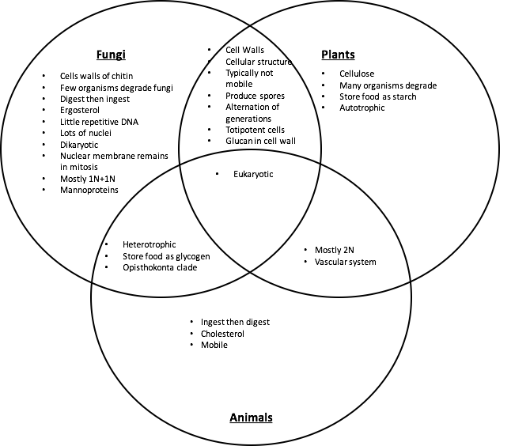
Figure 8. Venn diagram comparing similarities and differences of fungal, plant, and animal characteristics.

Plants and Fungi
The relatedness of fungi and plants has stumped scientists for generations. In the past, scientists were only able to observe morphological characteristics in these organisms and did their best to group them based on these features. Chemical taxonomy helped prove that fungi were physiologically distinct from plants in numerous ways (Figure 8). The aid of molecular genetic sequencing techniques has recently helped further unravel the many mysteries about the relatedness of fungi. Organisms believed to be fungi have been reclassified as protozoa (including oomycetes and the mycetozoan slime molds,); organisms believed to be protozoa (such as Chytrids, Microsporidia, and Pneumocystis jirovecii) were shown to be fungi.
As stated before, plants and fungi share a number of similar characteristics but there are also some key differences between the two. To begin, both organisms are eukaryotic and have membrane bound organelles, including a nucleus that houses the genetic material, deoxyribonucleic acid (DNA). However, fungi have relatively small nuclei with little repetitive DNA. Fungi can have one to many nuclei per ‘cell.’ Often these are genetically distinct nuclei when plasmogamy (the fusion of independent mycelial bodies) has occurred in the individual's history. Previously, separate individual mycelia may merge together in this way if they have appropriately-matched vegetative or mating compatibility types. Plants have relatively large nuclei that are typically diploid in all cells except the sex cells (like animals) that contain the instructions to produce many different, complex structures and molecules.
A structure that both plant and fungal cells produce, and which serves many of the same functions, is the cell wall. The cell wall permits both plants and fungi to form sturdy structures capable of above ground growth by adding rigidity to tissue. Cell walls also assist in growth through physical substrates by permitting turgid fungal hyphae and plant tissue to exert outward osmotic pressure without the cell membrane rupturing. This is a crucial factor for the apical growth of hyphae among fungi through a physical substrate (Money, 1995), as it is in root tips and pollen tubes among plants. Additionally, cell walls serve to protect the cellular components and organelles found within. Despite some similarities in function, the composition of the cell walls fundamentally differs between plants and fungi. Plants have cell walls composed of cellulose (and sometimes lignin) whereas fungi have cell walls of chitin.

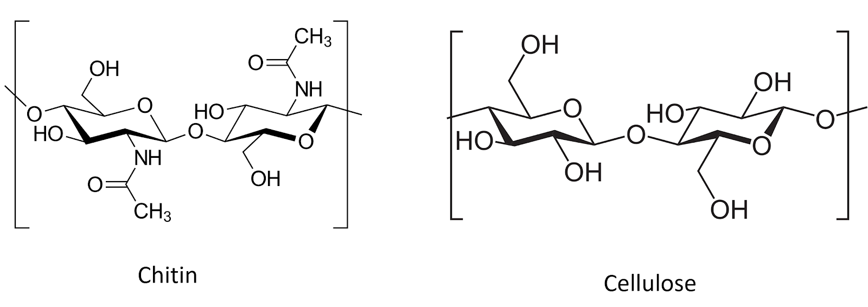
Figure #. Chitin and cellulose are both polysacharide chains of β1-4 linked monosacharide monomers. Chitin comprises chains of N-Acetylglucosamine monomers, whereas Cellulose is made of D-glucose monomers.

Due to the rigidity of the cell walls, both plants and fungi are generally sessile when mature. As sessile organisms, the lifestyle of plants and fungi are much different because of how each must acquire food. Plants are photoautotrophic and therefore able to produce their own food by utilizing sunlight energy to fix atmospheric carbon via photosynthesis. They also rely on root systems to gather essential elemental nutrients from the medium in which they grow. In contrast, heterotrophs are unable to produce their own food and must acquire nutrition from the consumption of other organisms or their byproducts (Figure #XXX)..
Fungi are chemoheterotrophic, meaning they must use chemical energy and acquire organic carbon (rather than inorganic carbon dioxide) from the environment. They are entirely reliant on acquiring nutrients and food from the environment. Ultimately, all of every fungi’s food is directly or indirectly sourced from carbon based molecules produced from the fixation of atmospheric carbon dioxide (CO₂) by plants. The same is true for ourselves as humans, as well as every other heterotrophic organism (save those lifeforms whose food is derived from the action of prokaryotic chemoautotrophs, such the extremophiles which survive in sulfur springs or anchor the food webs of deep sea vents).
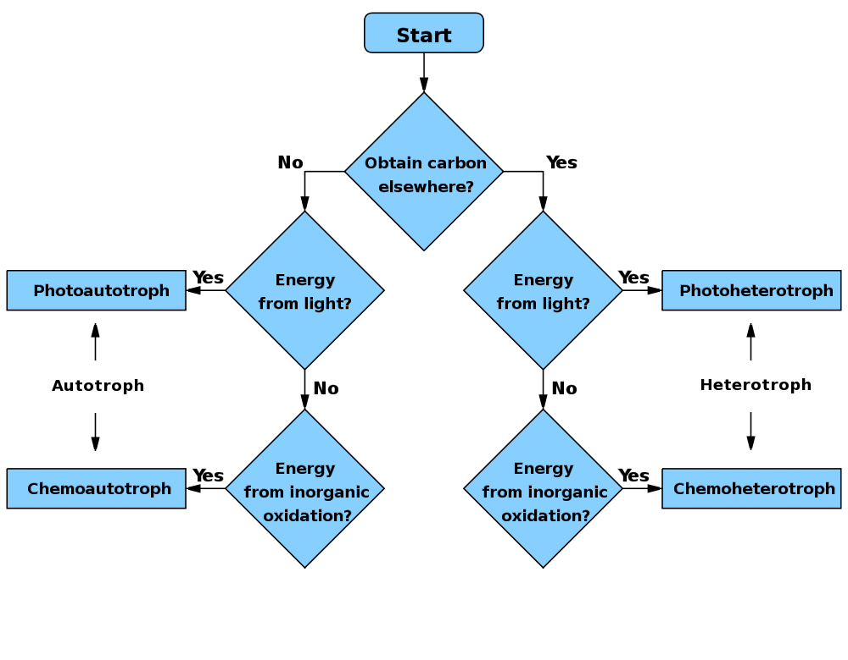
Figure #. WikiCommons user: Wickey-nl
While fungi are generally ‘non-motile,’ their cells are connected in such a way as to allow much of the cytoplasmic contents to flow through the tubular hyphae. In this way, a fungus can transport nutrients around its mycelium. While a fungus cannot move its existing body to a new location, they are able to exploit cytoplasmic flow in order to change or expand locations by growing hyphae in new directions, flowing their cytoplasm into the newly formed mycelial body, and walling off older sections of their mycelium. Thus, they may gain functional motility beyond that of most plants, despite lacking moving appendages and musculature, while maintaining a rigid cell wall which prevents ameboid movement via pseudopodia (although some yeasts can move in this fashion).
Another implication of being unable to move is that fungi, like plants, cannot evade predators. Therefore, they are forced to come up with alternate defense mechanisms. Plants can develop thorns and spikes as part of their physical structure to discourage predators from attacking, however, they also produce a variety of novel secondary metabolites that act as defense compounds. Some fungi have developed physical defense structures, such as lacticifers among Lactarius or the physical toughness of many perennial polypores, but the production of secondary metabolites to ward off competitors or predators is ubiquitous. Some of these compounds include famous antibiotics such as penicillin or the citric acid that is produced from Aspergillus niger fermentation. The plethora of secondary metabolites from fungi is astonishingly diverse and includes varying polyketides, terpenoids, terpenes, alkaloids, and peptides (Keller et al, 2005)..

Animals and Fungi

There are a number of other key similarities and differences in plants and fungi, however, as mentioned before, fungi are actually closer to animals than plants (Figure #XXX). Again, both organisms are eukaryotic with DNA contained in a nuclei and membrane-bound organelles. What makes fungi closer to animals than plants is the fact that they both evolved from the clade Opisthokonta. A common trait of this clade is mobile gametes at some point in the organisms’ lifecycle.
Obviously, most animals are mobile organisms that are adept at moving around to find nutrients and food, and evade predators. The lack of cell walls is important for permitting contraction and relaxation of muscle cells, on which animal movement depends. The relative rigidity of mature fungal cells conferred by cell walls prevents contractile-relaxation of tissue, as well as ameboid-like formation of pseudopodia.
Both animals and fungi are chemoheterotrophic. Nither can produce their own food and cannot use light as an energy source.Animals will ingest and then digest their food, whereas fungi digest (by releasing exoenzymes into the environment) and then ingest (by actively transporting nutrients back into the fungal body).
A physiological difference with practical implications between fungi and animals is the structure of sterols embedded in their cell membranes. Fungi synthesize ergosterol whereas animals synthesize cholesterol (plants also produce a diverse array of phytosterols). Both ergosterol and cholesterol are derived from the same precursor, Lanosterol (Fig. #XXX). Ergosterol and cholesterol serve similar functions including impacting membrane fluidity, cell signaling and other physiological processes. One reason we are focusing on this particular molecular difference between fungi and animals is that we can exploit the ergosterol pathway unique to fungi in order to develop and apply selective fungicides. Compared to prokaryotic pathogens and disease agents, parasitic and pathogenic fungi have much more in common physiologically with their eukaryotic plant and animal hosts. Therefore, ergosterol and its biosynthesis are particularly important targets for human and veterinary antifungal drugs.
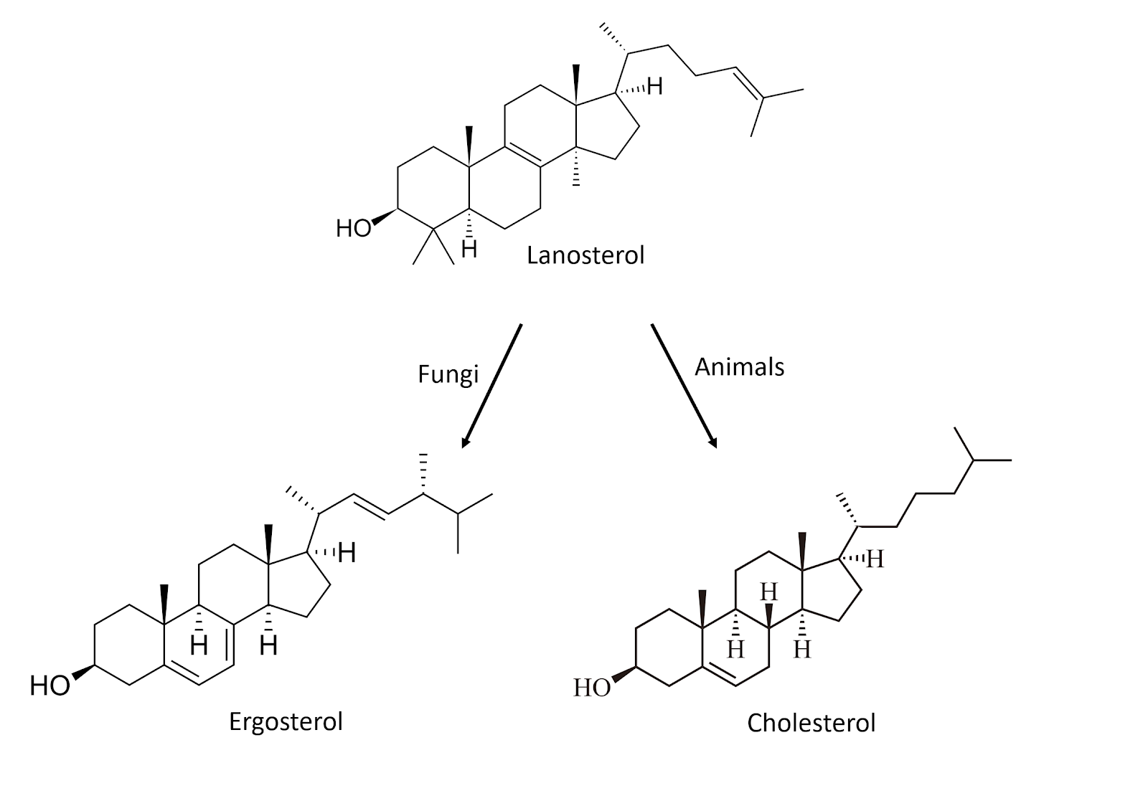
Figure #. Chemical structures for sterol compounds found in fungi (Ergosterol) and animals (Cholesterol)

Fungi are an extremely unique and diverse group of organisms that contain some characteristics not found anywhere else in nature. The varied growth forms are reliant on external digestion of substrate by secreted exoenzymes, followed by ingestion of the predigested food via absorption and endocytosis. That fungi can be mono- or dikaryotic, some with many nuclei per ‘cell,’ is not only fascinating, but allows fungi unique physiological and evolutionary paths to travel compared to uninucleate organisms. Also, most fungal cells can be a little different than one usually thinks of when considering traditional biological cells. Yeast cells may function relatively similarly to other single celled organisms, however, with filamentous fungi, the entire vegetative body is essentially one cell.

Sample Chapter #2
Ch 11. Powdery Mildew
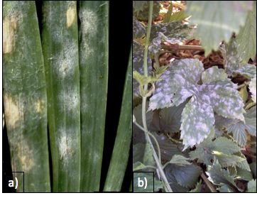
Figure 11.1. Leveillula taurica growing on onion plant (a) and Podosphaera macularis growing on hops (b). The fungi themselves can look pretty similar, even under microscopic observation.

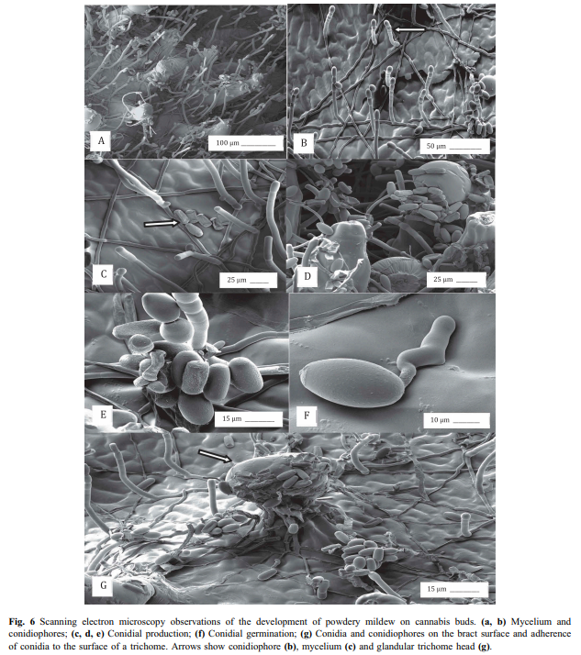
Taxonomy
Kingdom: | Fungi
Phylum: | Ascomycota
Class: | Leotiomycetes
Order: | Erysiphales
Family: | Erysiphaceae
Genus: | Golovinomyces; Podospheara ; Leveillula
Species:  unresolved | Golovinomyces ambrosiae (Syn. G. cichoracearum, G. spadiceus). Podosphera macularis; Leveillula taurica

Introduction
One of the most ubiquitous and well known of the fungal pathogens on Cannabis are the powdery mildews. Caused by multiple organisms, this dreaded pathogen first manifests itself as a white, cottony growth that begins to form on the top surface of leaves. Once conspicuous on the leaves, the spores of this fungus are likely to be everywhere in your grow, whether it is indoors or out. However, there are various effective treatments that can eliminate this fungus (depending on the stage and degree of severity) and practices that can be used for preventing this fungus from getting established in the first place. Most growers have experience dealing with this fungus at one point or another. In many regions, PM is so common that one should assume that there are always going to be mildew spores in the air, unless you are growing in a filtered indoor space. Even then, starting with an assumption that you have spores in your garden will help you to develop and maintain a solid Integrated Pest Management program (IPM).
Just like everything else in the Cannabis industry, there are some clear misconceptions about these fungi that can be misleading and very confusing. To start with the confusing common names, powdery mildews and downy mildews are not the same thing and should not be treated in the same way. Downy mildew, caused by an oomycete rather than a fungus, is less commonly seen on Cannabis crops, though growers should still be aware of the pathogen and the symptoms associated with it (see “Chapter 16: Leaf Spot Diseases” for more information on Downy Mildews).
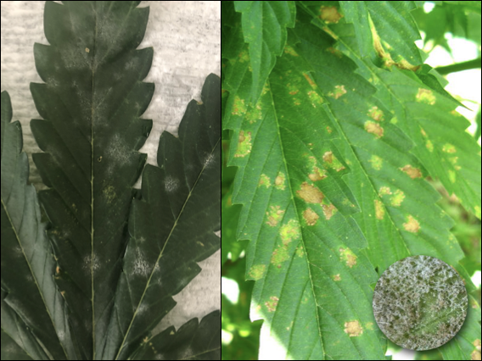
Figure 11.2. Powdery mildew on Cannabis leaf on left vs. downy mildew on Cannabis on right.

Elucidating the species of powdery mildews affecting Cannabis will assist cultivators in controlling the disease. Most species of powdery mildew are host specific and have limited alternate host ranges on which to hide from farmers whose crops may be affected (Table XX). Definitive knowledge of the species and pathovars affecting Cannabis will help us prevent cross-contamination from susceptible neighboring host plants. However, no matter which powdery mildew species you have any applied treatments will be the same.

Table XX. Alternative host range of powdery mildew species affecting Cannabis.
Species | Alternate hosts
Golovinomyces ambrosiae (Syn. G. cichoracearum, G. spadiceus). | Asteraceae (Acanthospermum, Ambrosia, Aster, Blainvillea, Chrysogonum, Coreopsis, Dahlia, Eupatorium, Gerbera, Helianthus, Lagascea, Laggera, Leucanthemum, Mauranthemum [Chrysanthemum s. lat.], Melampodium, Parthenium, Telekia, Tithonia, Xanthium, Zinnia), Fabaceae (Crotalaria), Malvaceae (Abelmoschus),Polygonaceae (Persicaria), Solanaceae (Solanum), and  Verbenaceae (Verbena).
Podosphera macularis | Humulus (americanus, lupulus, scandens [=japonica]), Moraceae
Leveillula taurica | Probably a species complex with unresolved host ranges:  Amaranthaceae (Amaranthus, Celosia, Gomphrena), Apocynaceae (Rauvolfia, Vinca) Aristolochiaceae (Aristolochia), Asclepiadaceae (Asclepias, Calotropis, Stapelia, Vincetoxicum), Bombacaceae (Asansonia, Bombacopsis), Burseraceae (Commiphora), Campanulaceae (Asyneuma, Phyteuma), Caricaceae (Coccinia, Cucumis, Cucurbita) Datiscaceae (Dattisca), Dipsaceae (Scabiosa), Grossulariaceae (Ribes), Daeodoraceae (Anigozanthos), Hydrophyllaceae (Phacelia), Hypericaceae (Hypericum), Linaceae (Linum, Reinwardtia, Malvaceae (Abelmoschus, Abutilon, Hibiscus), Martyniaceae (Martynia), Myrtaceae (Chamaelaucium), Oleaceae (Olea), Onagraceae (Clarkia Epilobium), Orobanchaceae (Leptorhabdos, Odontites), Plantaginaceae (Digitalis, Phlox, Polemonium), Polygonaceae (Polygonum, Rumex), Primulaceae (Samolus), Rosacea (Reseda), Salvatoraceae (Salvatora), Scrophulariaceae (Scruphularia), Tiliaceae ( Corchorus), Verbenaceae (Caryopteris, Lippia, Verbena).

There are accumulating reports identifying Golovinomyces cichoracearum sensu lato as the powdery mildew affecting Cannabis in Canada and France based on ITS sequencing (Pépin et al, 2018; Punja, 2018; Rodrigues et al, 2015) and G. spadiceus has been identified from Kentucky (Szarka et al, 2019). Unfortunately G. cichoracearum sensu lato is poorly defined phylogenetically, likely comprising many cryptic species. There is also evidence that the ITS sequence alone does not adequately discriminate among closely related Golovinomyces species (Punja, 2018). These mixed and unclear results are not all that surprising given the fact that Cannabis has been illegal to grow and most scientists did not have the ability to work with this plant. Also, molecular fingerprinting has only been around since the mid-1980’s, with many organisms yet to be sequenced.
Macpartland et al. 2000 documented two species of powdery mildew infecting Cannabis: Leveillula taurica and Podosphaera macularis. However, under current nomenclature systems Podosphaera macularis is host restricted among Humulus species only (Uwe Braun, personal communication). This is contradicted by recent cross infectivity experiments, at least in greenhouse envinronments ( Weldon 2018). Levieullula taurica was reported by Jaczewski, 1929, but has not been confirmed as a common cause of powdery mildew among Cannabis recently. A private lab also reported an unknown genetic isolate from Cannabis grown in the Northeast United States. They claimed a full genome sequence did not match any known Erysiphales in GenBank (a universal genetic depository for researchers), and that the northeast isolate was not a Golovinomyces (Medicinal Genomics).
Powdery mildew is an obligate biotroph, meaning that it requires a host plant in order to complete its life cycle (live, grow, and reproduce). This characteristic makes this organism incredibly difficult to study compared to saprophytic or necrotrophic fungi, since powdery mildews cannot be cultured in a petri dish or flask on nutrient media, rather they must be kept alive by growing the pathogen on a susceptible host plant. Additionally, powdery mildew can be extremely difficult to identify, even with a microscope. The keys that are available use very small, difficult to see features to distinguish among powdery mildew fungi. A major diagnostic feature for the identification of powdery mildew anamorphs (asexual state) are characteristics of the appressorium following conidia germination. Teleomorph identification can take advantage of the often unique, and beautiful, ornamentation on the sexual fruiting bodies (chasmothecia).
Accurate identification of many anamorphs is very difficult to impossible by diagnostic characters alone, and benefits from molecular techniques. Molecular techniques such as polymerase chain reaction (PCR) have enabled great strides in genetic sequencing, however these approaches also have drawbacks and are not widely available outside of academia and specialized private labs. Among fungi, the inter transcribed spacer (ITS) and ribosomal RNA of the large subunit (LSU rRNA) have often been used for phylogenetic analysis. Increasingly groups of genes are used to develop a consensus phylogeny, since single gene phylogenies based on the ITS sequence have been shown to be prone to error.

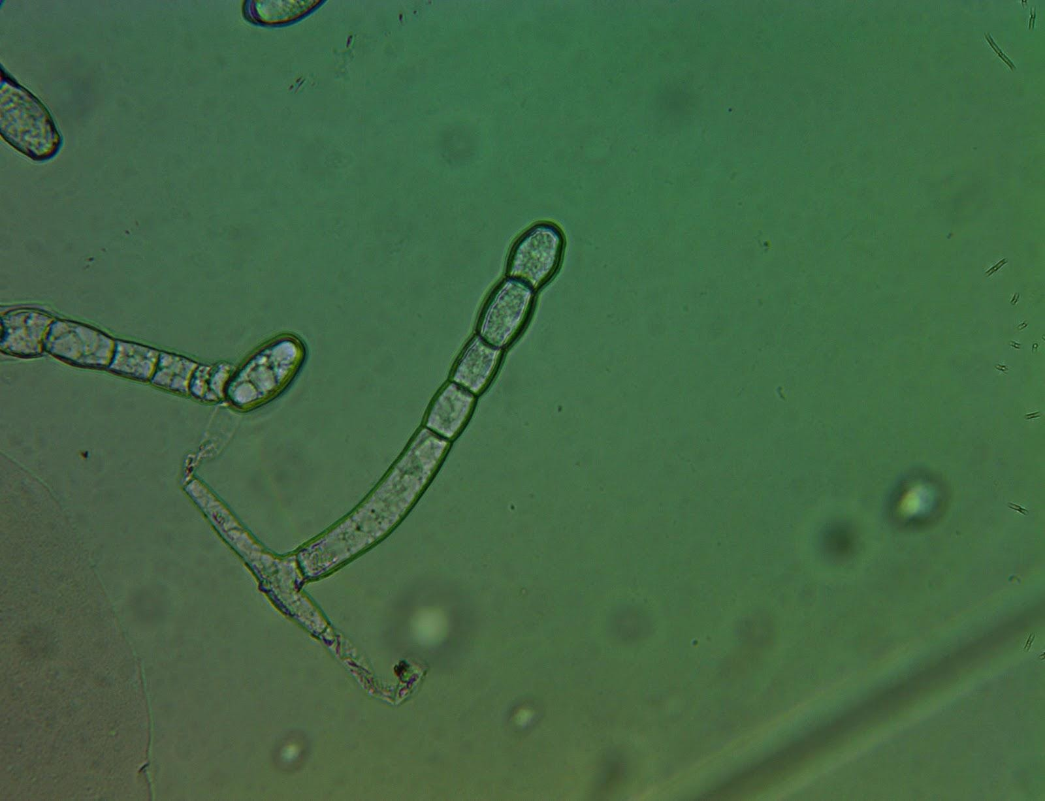
Figure 11.3. Powdery mildew (G. ambrosia) conidiophore found on Cannabis leaf surface grown in a greenhouse in Oregon. Tape mount at 40x

Like many other groups of fungi, the taxonomy of the Erysiphales (powdery mildews) is in a state of flux. As our understanding of the evolutionary relationships of each discrete species improves, names are changed and species are moved among taxonomic groupings so that our taxonomic system increasingly represents underlying phylogenetic relationships. There are certainly more than one species of Erysiphales affecting Cannabis which may have differing geographical distributions and host ranges. Definitive knowledge of the identity and geographic range of powdery mildew affecting Cannabis, as well as alternate host-plant species, will advance the ability of cultivators to effectively control pathogen outbreaks. It is likely that at least one of the PM species affecting Cannabis cultivators in North America has a relatively broad host range.
An occasional debate in the Cannabis industry is whether or not powdery mildews are systemic. All the scientific evidence that we have seen, in combination with direct observation and knowledge of fungal biology, points to powdery mildew not being systemic. For a pathogen to be systemic, the pathogen would be able to infect one point on the plant (say a leaf) and then travel within the plant to infect other, distant plant parts. Powdery mildews typically form superficial infections restricted to the epidermal tissue. Some species are known to penetrate into the deeper palisade layers of the mesophyll. Some form localized infections into the petiole. But no powdery mildew in the entire Order Erysiphales are known to form extensive systemic infections within their respective plant host (Uwe Braun, personal communication).
Farmers often observe large outbreaks on individual plants, fail to take clean clones from plants with infection elsewhere, or experience vertical, seed borne transmission; all of these suggest systemic infection. However, powdery mildews prolifically produces spores. The spores are then wind and animal dispersed, quickly traveling from one part of a plant to another or even throughout an entire garden. Therefore, once you spot the fluffy white mass growing on a plant, the fungus has most likely already began to produce spores and it is almost guaranteed that there are other PM spores in the air. Seemingly systemic infections are actually the coalescence of individual colonies, each representing an infection point.
The fact that powdery mildew colonies almost always manifest as circular growths indicates they are individual colonies. This is analogous to fairy rings or colonies in petri dishes, which expand outward from an original inoculation point in every direction. Seed borne transmission of powdery mildew is possible, however it is exclusively (or nearly so) due to conidia on the seed surface, rather than an infection within the embryonic plant body. Because of this, seed borne infections of powdery mildew can be prevented by surface sterilizing seed prior to planting.

Biology & Life cycle
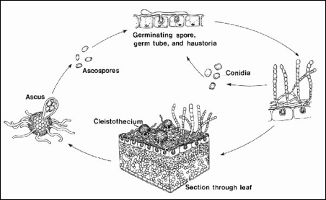
Figure 11.4. Life cycle of a typical powdery mildew fungus. Asexual reproductive structures (conidia) are commonly seen on Cannabis. Recently sexual fruiting bodies of G. spadiceus have been observed on Cannabis (Szarka et al. 2019). For other species of PM affecting Cannabis it may be that sexual structures may only form on alternate hosts or may have lost their sexual stage completely, persisting solely as fungi imperfecti. Alternatively, it may simply be that humans have not yet documented the occurrence of chasmothecia on Cannabis in all instances in which they may occur.

The life of a powdery mildew begins, like other fungi, with a spore (either a sexual ascospore or an asexual conidium).When a spore lands on an area that is suitable for growth it will form a germ tube, a primary hyphae strand. The hyphae will grow from stored energy, but quickly need access to nutrients for survival.
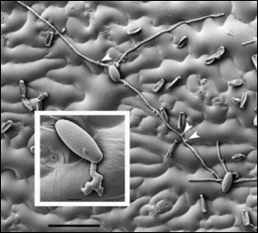
Figure 11.5. Scanning electron micrograph of germinating powdery mildew conidia on leaf surface. Arrows point to the appressoria forming a penetration peg to infect plant tissue.

As an obligate parasite, PM must invade host tissue in order to siphon off nutrition. In order to gain access to host tissue, a specialized structure, called an appressorium, capable of exerting high amounts of pressure onto a concentrated point on the plant surface is formed by the developing fungi (Fig. 5). Often appressoria will form above inherent weaknesses, such as directly above a stomata or at the meeting point between two epidermal cells. While a pressure peg exerts force on the leaf surface the hyphae also releases enzymes that degrade the cuticle and cell walls of the plant tissue it is trying to penetrate. If successful, the puncture peg will form a hole into the plant body through which it extends a specialized hypha termed, haustorium.
Haustoria are lobed, prong-like projections able to penetrate the cell wall of plant cells (though not the membrane). The haustorium becomes engulfed by the plant's plasma membrane, allowing the fungus to absorb nutrients from the plant in the extracellular space between the plant cell membrane and wall. A specialized, convoluted membrane is formed by the fungus within the space (called the extrahaustorial matrix) along the plant membrane in order to maximize the surface area across which it may absorb nutrients (Micali et al. 2010). The fungus now has a source of nutrients to continue to grow and mature. The fungus translocates this food throughout its entire body -including the epiphytic portions.
The mycelium can now form secondary hyphae which continue to spread endophytically to nearby plant cells, as well as epiphytically over the leaf surface and use appresoria to create new points of invasion through which the fungus may access more areas of the plant body. After a short period of vegetative growth in a conducive environment, the fungus will produce conidiophores. Erysiphales are capable of producing conidia in great numbers.
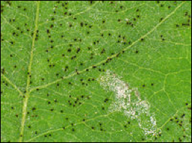
Figure 11.6. Powdery mildew chasmothecia (small black spots) growing on the underside of a leaf.

Until recently, only the asexual state had been observed on Cannabis. Szarka et al, however, observed G. spadiceus readily forming chasmothecia in autumn on Cannabis in Kentucky (2019). Podosphera macularis is also capable of forming chasmothecia on cannabis plants (Weldon et al, 2020). Chasmothecia (or formerly, cleistothecia), are the sexual structures formed by members of the Erisyphales (Fig. 6). They appear as dark, spherical structures made of tightly interwoven hyphae with simple appendages. Inside there are multiple asc, each containing 8 ascospores (Fig. 7). Once the asci and ascospores are mature, the chasmothecium will burst and the spores will be released and dispersed into the environment.
The usual lack of chasmothecia on Cannabis among may indicate a biological impediment to fruiting body formation when the most common powdery mildew species infects Cannabis. If so, there may be alternate hosts on which the sexual stage of the pathogen occurs. Alternatively, these races affecting Cannabis may have lost their sexual state, or such asexual populations are isolated from compatible mating types and only exist exclusively as an anamorph locally. This is the current state of the P. macularis population in the Pacific Northwest, where currently only the MAT1-1 type is known. Currently there is a quarantine targeting hop powdery mildew in the United States to prevent the introduction of the MAT1-2 mating type into the Northwest. The production of chasmothecia on Cannabis by P. macularis presents risk to the hop and Cannabis industries throughout the US by potentially facilitating the spread of sexual mating types into the PNW, which would be followed by a proliferation of pathovar genetic diversity (Weldon et al, 2020). Cannabis may also serve to move dangerous pathovars that are emerging in the PNW to new areas.
When sexual reproduction occurs in Erysiphales it may be homo- or heterothallic, depending on the species. This means that an individual may mate with itself (homothallic), or require a different individual (heterothallic) to form sexual spores.
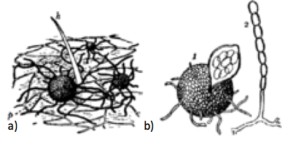
Figure 11.7. Podosphera macularis reproductive structures. Chasmothecia in the soil (a) and then a chasmothecia next to a conidiophore producing conidia to the right (b).

Powdery mildew can overwinter in the form of this resistant chasmothecia structure. Thus they can lay dormant in your soils or fields and then when the environment is sufficient for growth, the chasmothecia will open and release spores into the wind. If the spores land on a suitable host, the spore will germinate, a germ tube will form and the life cycle begins again.

Prevention
There are a wide variety of treatments for powdery mildew, both at the store and in the literature, and everyone seems to have their own opinions on what works best at what time. The old saying that an ounce of prevention is worth a pound of treatment is especially true when it comes to fungal diseases. The best way to deal with PM is to never get it in the first place. This is accomplished by having a strong IPM program, including set scouting schedules and good cultural practices.
In general, PM species affecting Cannabis thrive in warm, humid, and poorly lit conditions. Anywhere from 60ºF to 85ºF and humidity levels above 75% will create the perfect habitat for these fungi (Amsalem et al. 2006). Higher light intensity is associated with reduced disease incidence, with the shaded interiors of canopies being most at risk for PM infection (Amsalem et al. 2006). Large swings in day/night temperature and humidity can exacerbate the issue with some PM species (Mahaffee et al. 2003).
Many growers clean out the interior of canopies by defoliating and removing plant tissue, believing increased airflow will reduce powdery mildew infections. While this may actually reduce infections, the practice is likely effective due to increased light penetration, rather than or in addition to a localized reduction in canopy humidity. However, some researchers have noted that after harvesting equipment goes through the field and agitates plant biomass, disease pressure is increased (Correll et al. 1988). Regardless, maintaining a canopy with good light penetration and airflow seems to reduce PM incidence and severity.
The different species of powdery mildews will have slightly different ecological niches and may respond differently to cultural controls. As the science progresses and the species causing disease in Cannabis are better understood, more specific measures can be taken to help control PM. For instance, alternate hosts may be a significant factor in maintaining a reservoir for PM innocula. Knowing what other plant species are capable of serving as alternate hosts for the relevant PM species will greatly assist growers in keeping the local area clear of PM.
Leveillula taurica can also cause PM on onions and several other common garden plants such as eggplant, tomato, peppers, and others. This species has only been documented in the western United States, as this species prefers slightly drier, warmer climates. Podosphaera macularis commonly grows on hop plants, and has been frequently reported from the hop fields of Oregon and Washington (Mahaffee et al. 2003). This species prefers high humidity. A large swing in the daytime/nightime temperatures and humidity will also increase the chance of infection (Mahaffee et al. 2003).
Most PM species will produce conidia in great numbers, so it is very important to maintain daily scouting programs and preventative sprays if you are growing in conditions that are conducive to mildew growth. Once the white, powdery growths are detected, there are almost certainly going to be conidia all over your garden.
For preventative treatments, biological sprays and root drenches are recommended. A strong resident microbial community, both in your soil and in the phyllosphere (area surrounding leaf surface), has been shown to increase plants’ innate resistance to pathogens. Prophylactic treatment with compost extract can effectively reduce fungal diseases under field conditions (Weltzien, 1989). The idea here is that you will be inoculating the leaf surfaces with a growing community of healthy microbes. Many endophytic microbes are able to travel from the roots into aerial plant portions, so foliar sprays are not necessarily required to cause full-plant infection.. Beneficial microbes act in myriad ways to reduce PM infections.
Biological sprays could be a compost tea, a mixture of effective microorganisms, or plant fermentations (Weltzien, 1989). Commercial products are available of Bacillus subtilis, Bacillus amyloliquefaciens, Lactobacillus species, Streptomyces lydicus, and many others. Most of these commercial and naturally occurring symbionts act similarly (pathogen niche occupation, and by activating plant ISR). However, some directly antagonize disease organisms by producing antifungal compounds or acting as hyperparasites (Romero et al. 2006).
Streptomyces lydicus is an example of a microorganism that impedes powdery mildew growth through chemical defenses. This soil dwelling actinomycete (filamentous bacterium) produces many different novel metabolites. Some of these compounds that are excreted are antifungal and antibiotic in nature, and thus are very important in the agricultural and pharmacological industries. Natamycin is one such anti-fungal compound produced by Streptomyces lydicus (Atta et al. 2012). This compound will bind to ergosterol in the plasma membrane of fungi and inhibit protein transport, thus starving fungal cells of key nutrients and components they need to continue living eventually leading to the death of the fungus (Welscher et al. 2008). Natamycin is a broad spectrum antifungal compound and will target any fungus that contains ergosterol in the membrane, comprising all known fungi (Atta et al. 2012).
Strains of Bacillus subtilis have been shown to be effective at suppressing powdery mildews as well (Shoda, 2000). This is a very competitive bacterial species that is able to persist in harsh environments through the production of spores. In addition to being able to readily colonize leaf tissue, some B. subtilis stains produce myriad antifungal compounds including surfactin, fengycin, and iturin A or bacillomycin that enable this microbe to outcompete pathogens (Romero et al. 2006).
Other ways that biocontrol agents (BCA’s)are effective at reducing powdery mildew outbreaks is through the use of fungi that parasitize the pathogen targeted for elimination. In particular, Ampelomyces quisqualis is a hyperparasite on some powdery mildew fungi. A conidial suspension is typically prepared and then applied to infected plants. Once the conidia of the hyperparasite land on the PM, A. quisqualis conidia begin to germinate and invade the host tissue. This parasite will degenerate the host (PM) tissue by siphoning off nutrients from the host cytoplasm, thereby starving the pathogen (Kiss et al. 2004). The conidia, hyphae and sexual spores are all subject to invasion of the hyperparasite (Kiss et al. 2003). Use of A. quisqualis for biocontrol is limited by the obligate nature of the hyperparasite; at least some powdery mildew must be present for A. quisqualis to establish and repeated application of conidial solutions is required, however there have been successful reports of PM control among some crops (Gadoury). Further research is needed to determine the efficacy of using this biocontrol with Cannabis specifically.
A more widely proven antagonist of powdery mildew is Trichoderma harzianum (Elad et al. 1998). This BCA has several modes of fighting off pathogenic fungi. Trichoderma exhibits competition with PM for resources (food/light/space), produces antifungal compounds, acts directly as a hyperparasite of PM fungi, induces innate plant resistance, and can stimulate plant growth (Kiss et al. 2004). This BCA acts as a generalist (Naher et al. 2014), inhibiting the growth of a number of fungal pathogens.

Table 11.1. Common organic preventatives and treatments for Powdery Mildew that are acceptable for use on Cannabis. All sprays, even water, have some action by physically removing spores and hyphae from the plant surfaces.

Product | Active ingredient(s) | Mode of action
- Serenade  - Double Nickle | Bacillus subtilis  Bacillus amyloliquifaciens | - Direct competition  - Activates induced systemic resistance (ISR)
- GreenCure | Potassium bicarbonate | - Raise pH leaf surface  - Dries out mycelium due to osmotic potential
- Actinovate | Streptomyces lydicus | - Secretes antifungal compounds (natamycin)  - Direct competition
- Regalia | Raenoutria sachalinensis extract | - Activates induced systemic resistance (ISR)
- Elemental sulfur | Sulfur | - Interferes with several fungal life functions (e.g. spore germination)
- Bordeaux mixture | Copper sulfate and hydrated lime | - Copper ions inhibit spore germination, hydrated lime raises pH
- Neem Oil | Plant oils, azadirachtin and other terpenoids | - Antifungal compounds  - Physical barrier
- Dr. Zymes | Citric acid | - Unfavorable pH

Treatment
If preventative measures are not sufficient and symptoms of PM appear on leaf surfaces, there are still plenty of steps you can take to ensure minimum impact on your garden. The first step is to manually remove infected tissue. Spray the garden down with a high pH solution or elemental sulfur to limit spore movement and disrupt fungal growth before removing infected material. Researchers have shown that spraying the plants down, even if it is with just plain water, can reduce disease incidence (Jarvis and Slingsby 1977). Conidia do not do well when saturated in water (Perera 1972). Place infected leaves into a container and frequently disinfect your hands and shears as you perform this maintenance.
Perhaps one of the oldest treatments for powdery mildew comes from the vineyard growers of Europe (Martin, 1932). The Bordeaux mixture stems from the early 1900’s and is a mixture of copper sulfate and hydrated lime. This treatment is approved for use in organic production and is very effective at inhibiting fungal growth. The copper ion prevents conidia germination and the hydrated lime raises the pH of the leaf surface to a point that the fungus cannot tolerate (Somers, 1965). This is best used as a preventative treatment although has been shown to be effective as a contact fungicide, killing the fungus after it has gotten a foot hold.
Other common treatments include baking soda (sodium bicarbonate), potassium bicarbonate, elemental sulfur, neem oil, boron, or high silicon fertilizers (Bowen et al. 1999). There have also been reports of varying concentrations of milk being an effective treatment for the reduction of powdery mildew (Fig. 8)(Bettiol 1999, Crisp et al. 2006). Although no one is certain why milk is an effective treatment, researchers hypothesize it could be due to free radical production, antifungal fatty acid presence, or simply an osmotic imbalance (Crisp et al. 2006)
Different situations will determine which treatment will be most appropriate. For instance, you do not want to be spraying elemental sulfur on flowering plants, especially if they are destined for extraction. Doing so will result in a burnt rubber aroma in the concentrated product. Using a cocktail of multiple ingredients or rotating products that have different modes of action seems to be a logical and effective way to treat infected plants. This way the fungus is less likely to develop a tolerance or resistance to any particular ingredient.
When possible, the environment of your space may be controlled to discourage PM growth. This could include raising your temperature and decreasing the relative humidity of your room, or increasing light intensity. Whole garden heat treatments (holding the garden at 100ºF for 2 hours) may reduce fungal growth (Perera, 1972). Ultraviolet light treatment systems can significantly reduce fungal inocula and subsequent disease (such as the CleanLight Pro or similar device).

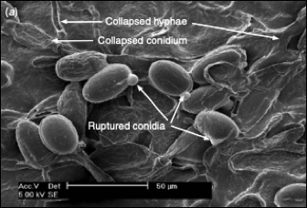
Figure 11.8. Scanning electron micrograph of powdery mildew hyphae on leaf surface 24 hours water a 1:10 milk:water dilution. The conidia and hyphae are collapsed from the milk, possibly due to free radicals formed when milk is applied and plants exposed to light (Crisp et al. 2006).

Remediation
Powdery mildew affected flowers can be rinsed in water during harvest to minimize fungal load. Powdery mildews are not toxic or pathogenic to humans, though affected flower is of lowered quality. Some forms of extraction may effectively remediate mold affected Cannabis (See Table 17.6).

